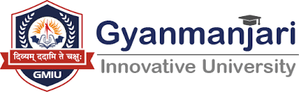

Gyanmanjari Institute of Management Studies Bhavnagar

Report on
Expert Talk
___________________________________________
Date: | 11/08/2026
Time: | 10:00 AM to 12:00 PM
Venue: | SF 8

No. of Student | 43
Department | Management
Semester | 3
Faculty Co-Ordinator | Prof. Tulsi Kondhiya

Objective:
The objective of the Expert Talk Program conducted as a TPA (Training and Placement Activity) is to provide students with valuable insights from experienced industry professionals, subject experts, and academicians. The program aims to bridge the gap between academic learning and industry requirements by exposing students to current trends, practical knowledge, professional skills, and career opportunities. It also helps students understand the expectations of employers, develop awareness of emerging technologies and practices, and enhance their confidence and preparedness for future employment.

About Activities:
The Expert Talk Program is an interactive TPA activity organized to facilitate knowledge sharing between students and experienced professionals from relevant industries or academic fields. During the session, the invited expert shares practical experiences, industry insights, career guidance, and information about current developments in the respective field. Students get an opportunity to interact directly with the expert, ask questions, and clarify their doubts regarding technical skills, career paths, workplace expectations, and professional growth. The activity promotes experiential learning, encourages students to explore new career possibilities, and helps them develop the knowledge and competencies required to succeed in the professional environment.

Photographs:
